**DATA STRUCTURE PRACTICAL NO. :-01**

**AIM :- ARRAY OPERATION**

**[A] : Take a number from user and write a program to search a specific number is present or not.**

**PROGRAM:-**

#include<iostream>

using namespace std;

int main(){

int a[6];

int n;

int position= -1;

int i;

for(int i=0; i<6;i++){

    cout<<a[i];

}

for(int i=0; i<6;i++){

    cin>>a[i];

}

cout<<"enter the number in array:" ;

cin>>n;

for(int i=0; i<6;i++){

if(n==a[i]){

    position=i;

    break;

}

}

if(position!= -1)

{

    cout<<"element is  found";

}

else{

     cout<<"element is not found";

}

return 0;

}

**Output:**

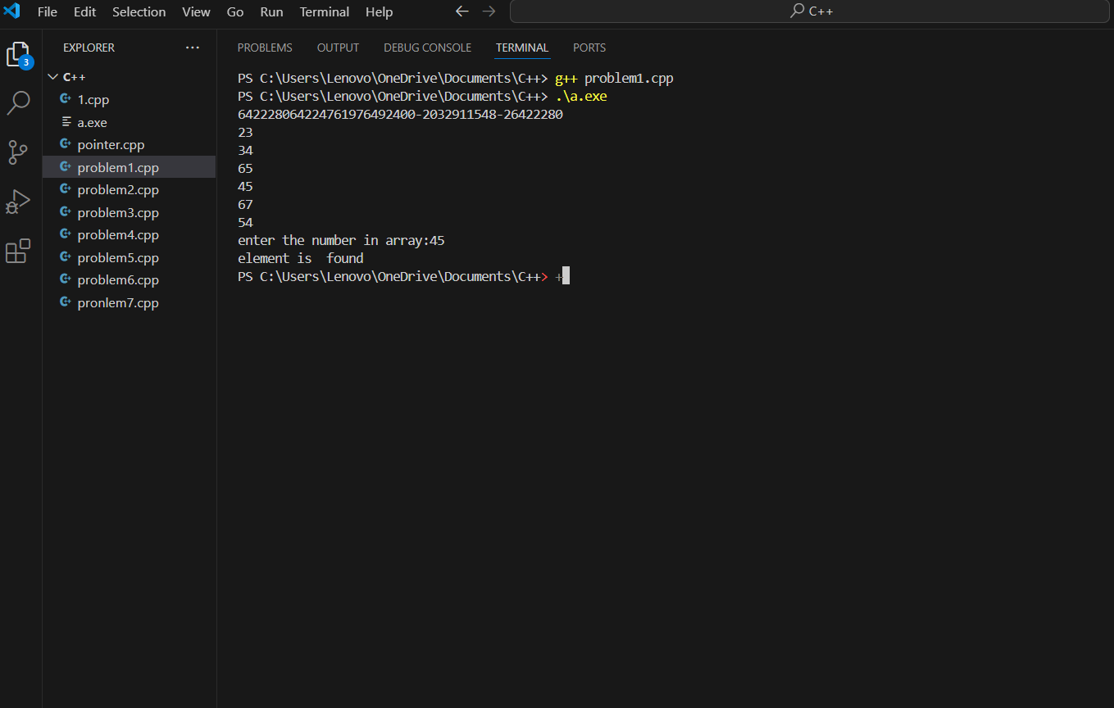

**[B] :- Create an array of any size. Write a program to update or modify some element from array.**

PROGRAM:-

#include<iostream>

using namespace std;

int main(){

int a[100], n ,b;

int position;

cout<<"entere the array size" ;

cin>>n;

for(int i=0;i<n;i++){

    cout<<a[i];

}

for(int i=0;i<n;i++){

    cin>>a[i];

}

cout<<"entere the position:";

cin>>position;

if(position<0||position>n){

    cout<<"invalind position";

    return 1;

}

cout<<"entere the new value";

cin>>b;

a[position]=b;

cout<<"new array"<<endl;

for(int i=0;i<n;i++){

    cout<<a[i]<<" ";

}

cout<<endl;

return 0;

}

**Output :**

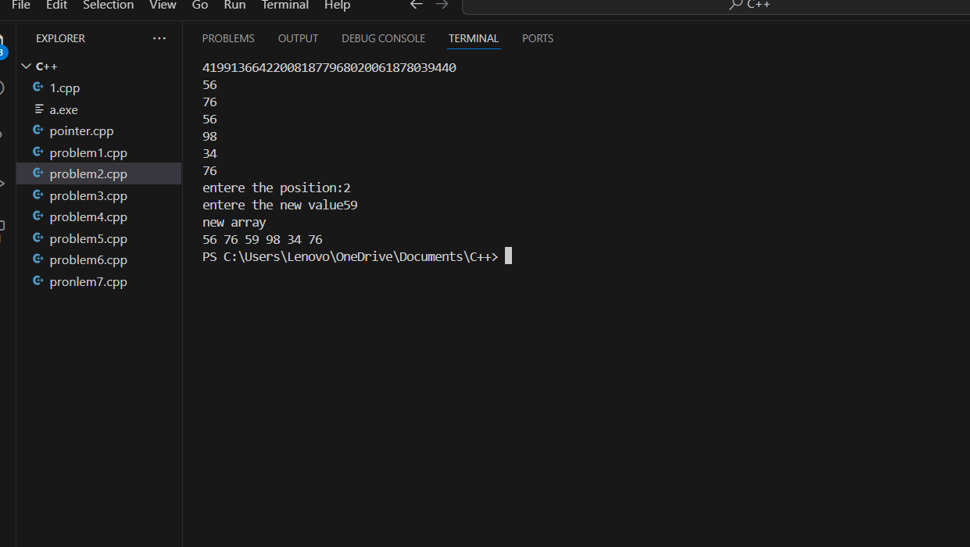

GITHUB LINK OF PRACTICAL No. 01 :-